DEPARTMENT OF BASIC SCIENCES AND ISLAMIAT
University of Engineering and Technology, Peshawar Campus
Assignment NO.3

Q1 (a) Determine whether the given set together with the given operations is a vector
Space. The set of all positive real numbers with the operations 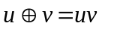
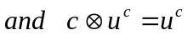.
(b) Determine whether the given subset of 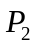is a subspace.
The set of all Polynomials of the form
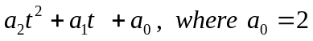

(c) Verify which of the following subsets of 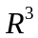 are subspaces of
(i) 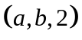
(ii) 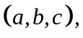Where 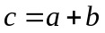
(iii) Where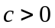.

Q2. (a) Let V be the vector-space 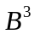and let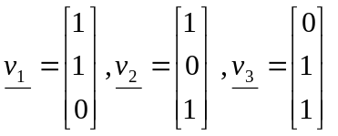. Compute
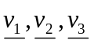. Is Span V?

(b) Determine whether the given set V is the set of all ordered pairs of real numbers (x, y)
is closed under the operation  and 
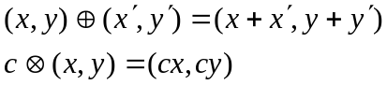

Q3. (a) Discuss basis for a vector space.

(b) Does the following set of vectors form a basis for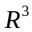?
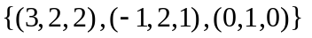

Q4. (a) Find the Characteristic polynomial, eigenvalues, and eigenvectors of the matrix
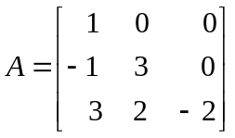

(b) Find a 2x2 nondiagonal matrix whose eigenvalues are 2 and -3, and respective
Eigenvectors are
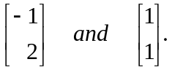

Q5. (a) Show that the set 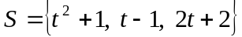is a basis for the vector space 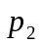

(b) Consider the subset 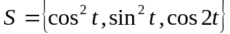 of the vector-space of all real-valued
Functions. Find the basis for the sub-space W=spanS. What is dimW?

Q6. (a) Find a basis for the solution space w of the bit homogeneous system.
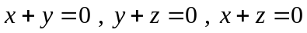
(b) Let A be (7x3) matrix whose rank is 3.Are the rows of A linearly dependent or
linearly independent? Justify your answer.

Q7. (a) Compute the nullity of the matrix 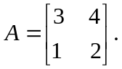

(b) Find all the eigen-values and associated eigen-vectors of the matrix
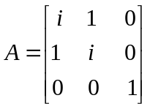
Q8. (a) Discuss subgroup of a group. Determine whether the set of all vector of the
form (a,b,c,d) where a>0 and b<0 is subspace of 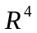

(b) Find, if possible, a nonsingular matrix p such that 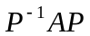 is diagonal
